Rolling Downhill

Students will view a drawing or picture and describe what they think will happen, prompting vocabulary.

Prompt for picture: What do you think will happen? Why will it happen?

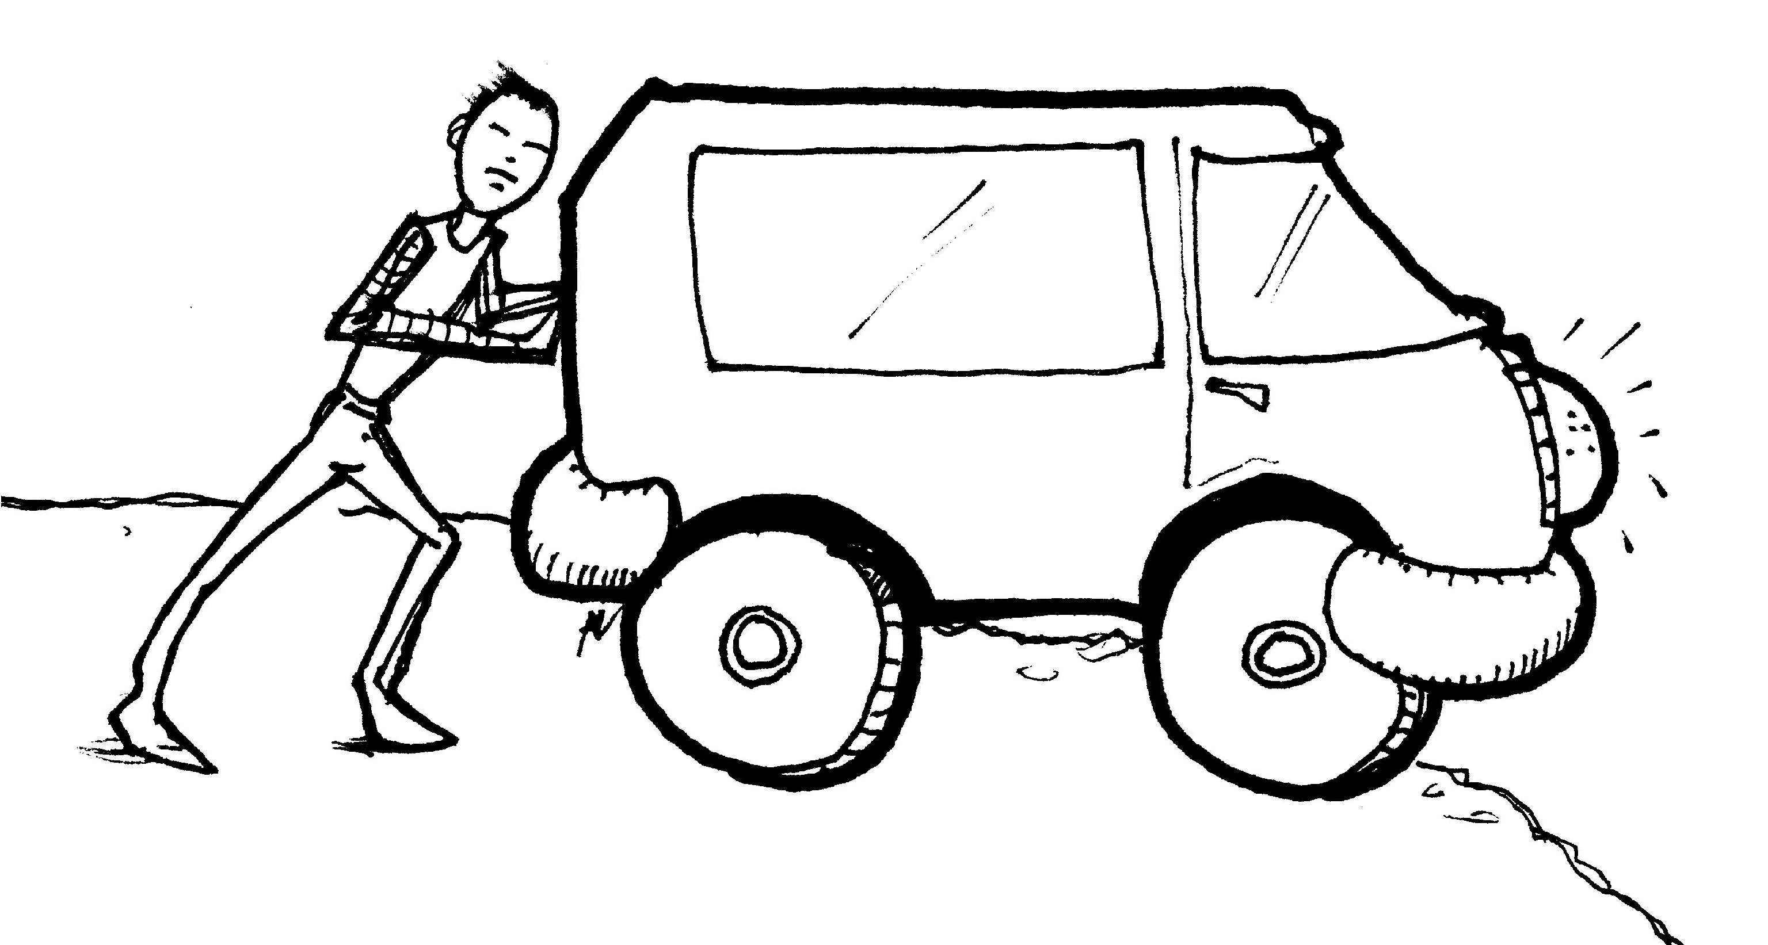

Examples of Vocabulary Development
hill move roll down
wheels heavy fast slow
push crash slide force
motion diagonal ramp forward

Potential Responses

-The truck will roll down the hill
-The wheels will make it roll
-The truck is heavy and it will fall down
-When you push the truck, it will move forward.

