Computers Unwrapped: An elementary curriculum exploring how computers work
Prepared by Gary Benenson, benenson@ccny.cuny.edu, October, 2024

Table of Contents
Summary | 1
Appendix:
Detailed lesson plans, worksheets and templates
Circuits | 3
Codes | 10
Information | 17
Communication | 26
Overview
The City Technology Project, based at the City College of NY School of Education, has developed a new and unique computer curriculum. All or nearly all of the current K-12 Computer Science curriculum efforts in the US are focused on programing or coding. While this is an important skill, it is equally important that we demystify the computer by showing what’s inside them. The materials described below have been part of undergraduate and graduate courses at City College School Education and have been tested in upper-grade elementary classrooms in Central Brooklyn public schools. These materials consist of units on Circuits, Coding, Information and Communication. Each unit is summarized below. The Appendix consists of a detailed Lesson Plan for each unit, including templates and worksheets.
Circuits
This unit begins with the construction of simple circuits including an LED and coin battery. Students are challenged to make the LED light up, and then to make and include switches in their circuits. They then explore the operation of this simple circuit using a circulating penguin toy as a model for explaining concepts of source, load, conductor, insulator, voltage and current. Finally, they create “electric puppets” whose two eyes light up when a hidden switch is closed.
Codes
Computer programming is commonly called coding, but what are codes and how are they used in computers? This unit begins with symbols, which are the components of codes. Students identify common graphic symbols, such as those found on common signs. A code is just a system of symbols. Examples of codes are Braille, ASL, sets of fabric care symbols, map legends, music notation, football referees’ signals, text message abbreviations and emojis. A key is a translation of a code into everyday language. Students create keys for their favorite emojis. Computers operate using binary code, which uses only two symbols, 0 and 1, in contrast with decimal which has ten symbols. In the decimal system, the columns have place values of 1, 10, 100, etc., increasing by a factor of 10 from right to left. In the binary system, the place values are 1, 2, 4, 8, etc., increasing by a factor of two from right to left. Decimal and binary are base 10 and base 2 number systems, respectively. Mostly we use base 10, but sometimes also other bases, such as base 2 for measuring length and fluid volume; base 5 for counting by tally marks; and bases 12, 24 and 60 for time measurement. Students learn the binary system and use Binary Cards to translate their birthdates from decimal into binary by selecting the columns they need. They then represent these binary numbers using LEDs of different colors to represent 0 and 1.
Information
Computers use codes to represent information. The basic unit of information is the bit, which stands for binary digit, and could be either a 0 or a 1. The Information unit begins with examples of one-bit messages, such as a knock on the door. To add information, you can knock softly or loudly, once or repeatedly. Computers handle information in digital form, which has discrete possibilities, but there are other devices that use analog information, which can vary continuously. Light switches are digital, while dimmers are analog. Students look at a variety of devices, and sort them according to whether they handle information in analog or digital form. To measure the amount of information in a number, students play a guessing game to determine a secret number between 1 and 100. How many yes/no questions do you need? The instructor then plays the game against the class and finds the secret number by asking seven questions or less. The original number is translated into binary and then converted back to decimal.. Other examples of information representation are seven- and fourteen-segment displays found on digital clocks and microwaves, and 35-bit 5 x 7 arrays found on street signs, store displays, trains and buses. Students learn how this works by playing a game using counters to create numbers and letters on a 5 x 7 grid.
Communication
Here we develop the solution to the problem of getting data from one place to another. This task involves a source, a receiver and a channel, each of which may introduce errors. Redundancy is used in both ordinary life and computers to detect and or correct errors in transmission. Students send one another messages with letters or words removed. Is it still legible? Computers use parity bits to add redundancy. Students explore parity by learning a “magic trick” which uses row and column parity bits to find a secret error introduced by the students.

Circuits
Materials
Ducklings climbing stairs toy (assembled, and with batteries installed) – available for $8 or less from http://temu.com
CR 2032 Coin batteries (one or two per student)
LEDs (three or four per student, assorted colors)
Double-sided foam tape
Masking tape
1 ½“ Brass paper fasteners: 2 boxes of 100 each
Card stock -- 65 # wt. or greater, assorted colors
Sample switches: push button, rotary and slide (see Table 4, p. 7)
Scissors
Cardboard or chipboard rectangles, approx.. 3” x 4”, one per student
Ballpoint pens for poking holes,
Materials for testing as conductors or insulators (in addition to those listed above): buttons, coins, fabric, paper, aluminum foil, plastic wrap, pipe cleaners, chalk, crayons, washers, etc.
Craft materials for customizing
- Batteries and LEDs: Distribute LEDs and coin batteries.
Individual Activity: Turn on the LED. Keep track in your notebook of the following:
a) What do you notice about the battery and the LED?
b) When you try to turn it on, what works and what doesn’t work (use diagrams).
c) What limits are there when you try to light more than one LED from the same battery?
Students are likely to discover that the battery can light up multiple LEDs of the same color, but some colors will not light up together. For example, if you light up a blue LED, and then add a red one, the blue one will turn off.
d) Which combinations will light up together, and which ones will not?
- Models
If you were able to make the LED light up, you created an electric circuit. How does it work? Unfortunately, we can’t see inside the circuit to answer that question. However, a common strategy for understanding a system that is too small, too big or otherwise invisible to create a model of it.
Class activity: Scavenger hunt for models used by children, in the classroom or elsewhere. For each model, list the real thing it represents, what is similar between the model and the real thing and what is different. For example, a doll represents a person, both have similar body parts, but the doll is usually smaller, made of different materials, and definitely not alive! A globe represents the earth, but has many fewer features, and is much smaller.

- Ducklings Climbing Stairs Toy
This toy provides a useful model of an electric circuit. Ask the class the following questions:
- In a circuit, what do you think is traveling around?
- In the toy, what do you see traveling around?
- In a circuit, what gives the electrons the energy they need to light up the LED, and what kind of energy is it?
- In the toy, where do the ducks get their energy, and of what kind is this energy?
- What would happen to the ducks if you disconnected one end of the ramp from the stairway? What would happen in the circuit if only one wire from the LED was attached to the battery?
- If you wanted to give the electrons more energy, what could you do? How could you change the stairway to give the penguins more energy?
Develop the idea that the toy is a model of an electric circuit. You can’t see the electricity in the circuit, but in the toy you can actually see the animals. Even though they are different, the toy can help you think about what’s happening in a circuit.
Class activity: Complete a comparison chart showing the analogies between an electric circuit and the penguin toy (see Table 1, below).
Table 1: Ducklings Toy vs. Electric Circuit
Issue | Toy | Electric Circuit
What is traveling around the loop? | ducklings | electrons
What keeps them in line? | the ramp | the wires
What gives them the energy they need? | the stairway | the battery
What kind of energy is it? | gravitational | electrical
How do they lose this energy to another form? | by rolling down the ramp | by lighting the LED
How could you increase the energy? | Make the stairway higher | add another battery
Measuring the energy per moving object | Height of ramp | voltage
Flow rate of moving objects | Animals/ minute | current
- Why do some LEDs not work together?
LED stands for Light Emitting Diode. A diode is a device that can conduct electricity in only one direction – somewhat like a fire exit that you cannot enter. This is the reasons why it will not turn on unless the long (+) wire of the LED is attached to the + side of the battery, and the short wire to the – side. Another property of a diode is that when it conducts, it limits the voltage across it. However, this limit is different for LEDs of different colors. Red LEDs use the least voltage, while blue LEDs use the most. Therefore, a red LED cuts off at a lower voltage, preventing the voltage from rising to the higher level needed to turn on the blue LED.
- Conductors and Insulators
Some materials can conduct electricity, while others cannot. Make a list of the available materials and predict which ones will conduct electricity. Then test each one by placing it between one side of an LED and the wire from the LED. If the LED still lights up, the material is a conductor; if not, it is an insulator. See diagram below:
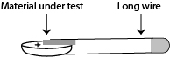
Individual activity
Make a list of the available materials, and predict which ones will conduct electricity. Then test each one by inserting it between the long wire of the LED and the plus side of the battery, as shown below. How will you be able to tell if the material is a conductor or an insulator?
- Switch Hunt
Nearly every electrical appliance has a component that has been missing from the circuits we made. You have to be able to turn it on or off. The device that does this is a switch, which is the basic control element in an electric circuit.
Class activity: To get an idea of the variety of switches, let’s conduct a scavenger hunt for switches – Switch Hunt for short. For each switch you list, identify also what it controls, where you find it and how you operate it. List only switches that you operate by hand. Do not include switches that work automatically such the switches that turn on the refrigerator light or the dome light in a car. The list should include switches that you operate in different ways, such as by turning something, flicking it pushing down or sliding. Table 2 will get you started.
Table 2: Switch Hunt
Where can you find it? | What does it control? | How do you operate it
Entrance of the room | lights | Flick it up or down
- Make a switch. A switch works by touching two conductors together to turn something on, and separating the conductors by air, an insulator, to turn it off.
Looking the results of the Switch Hunt, it should be clear that some switches stay in place after you operate them, while others need to be held in place. Some switches have to be rotated, while others are operated by sliding them, pushing down or perhaps pulling a chain. The names of common switches are shown in Table 3. You can create most of these kinds of switches yourself using paper fasteners and cardboard or cardstock.
Table 3: Basic Switch Types
Type of switch | How you operate it | Typical use
Push button | Push and hold it down | Keyboard
Toggle | Flick it | Light switch
Rotary | Turn it | Electric fan
Slide | Slide it | Penguin toy

Group activity: Using cardstock and paper fasteners create a push button switch, a rotary switch and a slide switch. For hints and suggestions, see Table 4 below.
Table 4: Ideas for making simple switches
Type | Materials | How to make it
Push-button | Two paper fasteners, cardstock | Attach the fasteners so that the leg of one can be pushed down to touch the head of the other, and so this same leg will spring back up when released. | 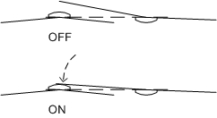
Rotary | Two paper fasteners, cardstock | Push both fasteners through the cardstock, about and inch apart. Keep one leg of one fastener on top. Rotate this leg so it is touching the top of the other fastener to turn the circuit on, and away to turn it off. | 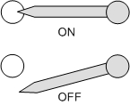
Slide | Three paper fasteners, cardstock | Cut a slot for one paper fastener, and poke holes for the other two. Mount two paper fasteners through the holes with heads up, and mount the third though the slot with both legs up. The legs turn the circuit ON by touching the two heads, and OFF by sliding away from them. | 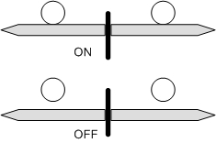
- Insert a switch in a circuit
Now that you have a switch, you can add it to a circuit to control a LED. The word “switch” does not really reveal much about what it does or how it works. A more expressive word is the Spanish word for switch, interruptor, which suggests that the role of the switch is to interrupt the current. The switch should be put in a position where it breaks the flow of electricity when it is in the OFF position, and restores the follow when it is ON.
The simplest idea is to use one of the wires of the LED as a pushbutton switch. Here is a diagram:
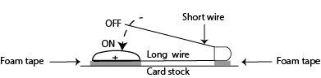
Group activity: Insert your switch into a circuit so it can turn the LED ON or OFF.
- Schematic diagrams How can we represent the circuits we have made? A drawing or diagram is another kind of model, because it shows what’s important without including details that do not really matter.
Individual activity: Make a drawing of your circuit.
Gallery walk: Post all the drawings and ask the class to examine each one. They can use Post-Its to write comments or observations.
Class discussion:
- What did you notice about the drawings?
- How were they different?
- What features make a circuit drawing easier to understand?
- Could you reproduce the circuit using only the drawing?
Develop the idea of a common visual language that everyone could use to understand each others’ circuits. Engineers, who design circuits for a living, have develop such a language, which they use to create schematic diagrams. The language includes both symbols for representing circuit components, and rules for arranging them in the diagram. The symbols used in schematic diagrams are yet another example of a code, and the key to this code is shown below.
Key to circuit symbols used in schematic diagrams
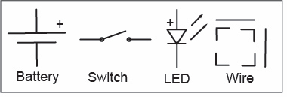
The rules for arranging the symbols are another form of standardization, which make a schematic diagram easy to read at a glance.

Rules for Making Circuit Diagrams

Use horizontal or vertical straight lines to represent wires between circuit parts.
- Use square corners between horizontal and vertical lines.
- Put the battery on the left and the LED on the right.
- Put switches on top.

Individual activity: Using the standard symbols and rules, create a schematic diagram that represents your circuit.
Gallery walk: Post the diagrams and repeat the gallery walk.
Class discussion:
- How is a diagram different from a drawing?
- What are the pros and cons of using diagrams instead of drawings?
- How well did the diagrams follow the rules?
- How would you correct them?
- What information does a diagram leave out, which a drawing might include?
- How important would this information be to someone trying to understand your circuit?
- How important would it be to someone trying to reproduce it?
10. Make an electric puppet
The culminating activity utilizes the lessons just learned to create an electric puppet. It has two LED eyes, one coin battery and a switch fashioned from a paper fastener. See next page for directions on how to make one.
Materials for making a puppet
- 1x cardboard sheet, approx. 3” x 4”1x coin battery
- 2x 10 mm LED
- 1x 1½” paper fastener
- Double-sided foam mounting tape
- Masking tape
Recommended vendors
LEDs
- https://protosupplies.com; Search on LED -- select 10mm, red, green and/or yellow; pack of 5 each @ $0.69
- https://www.adafruit.com/product/847 blue, pack of 25 @ $10
- www.digikey.com Search on Product # 5032-333296-ND Pack of 1 3@ $2.77 includes: 3x red, 3x blue, 3x green, 3x yellow, 1 white
Coin batteries:
- https://batteriesandbutter.com Maxell CR2032 @$0.35 each or less
Brass paper fasteners:
- www.officesupply.com Product # ODFN613332 1.5 inch fastener, box of 60 @$2.39

Directions
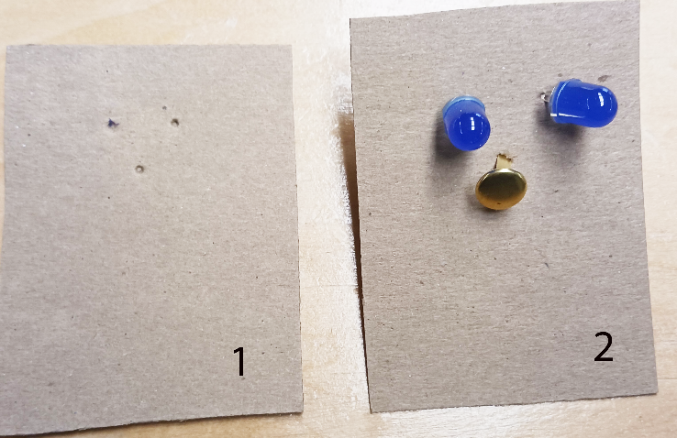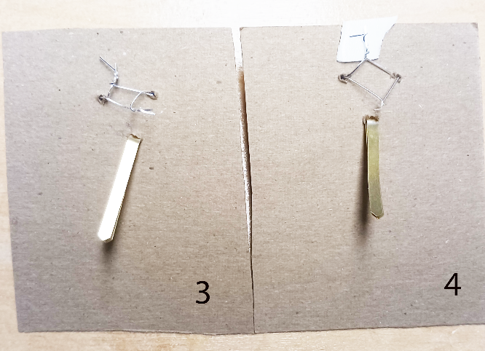
- Take a piece of cardboard, at least 3” x 4”. Using a ballpoint pen, poke three holes in the pattern of two eyes and a nose about ½ “apart. | 3. Flip the cardboard over, press the two long LED wires together towards the top and the two short wires towards the bottom. Then twist each pair of wires together. Bend the legs of the paper fastener down.
- Push an LED through each of the top holes and a paper fattener through the bottom hole. | 4. Place a small square of double-sticky mounting tape under the long leads and press them onto the tape
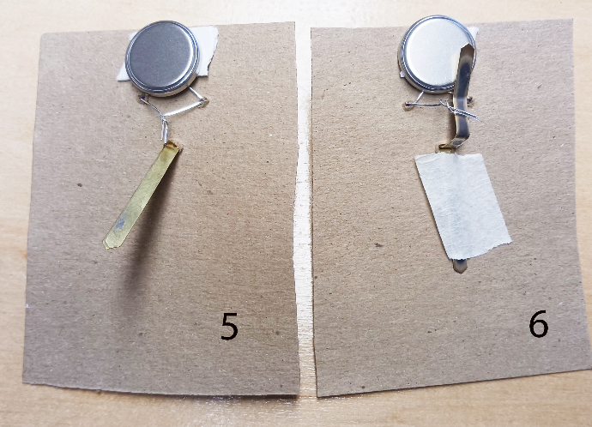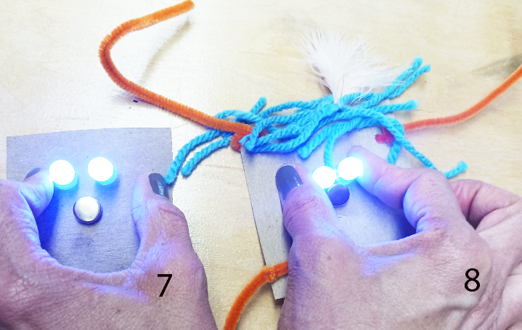
5. Press the flat (+) side of the coin battery on the tape, so it touches the long wires. | 7. Flip the cardboard over again and press down. If the leg of the paper fastener touches the battery, the LED eyes will light up!
6. Bend one leg of the paper fastener towards the battery. Wrap the two short wires around this leg. Use masking tape to secure the other leg, and make a better connection with the wires | 8. Customize your electric puppet using craft materials.

Codes
Materials
Template for making binary cards (one per student) – See P.16
Index cards 3 x 5” (five per student)
Glue sticks
Chipboard or cardboard sheet, approx. 5 ½ x 8”
LEDs, 4 or 5 per student
Paper fasteners, 2 boxes of 100 each
Double-sided foam tape
Masking tape
Craft materials for customizing
- Symbols: What are they? Why do we use them? How do we use them?
Individual Activity: Below are none common symbols found on signs. Draw each one and explain what it means. What other symbols can you think of?

- Codes: A code is a system of symbols. To understand a code, there is often a key, which translates the symbols in a code into a familiar language. On a map, the key is called a legend. Examples of codes & keys are shown below:
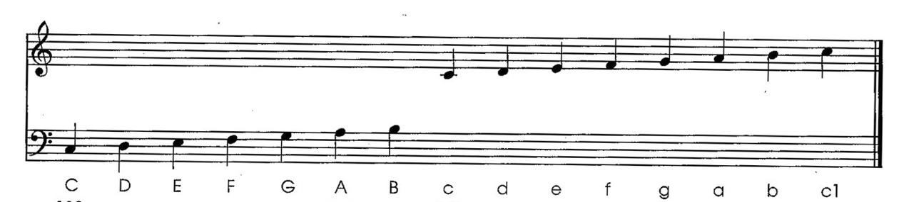
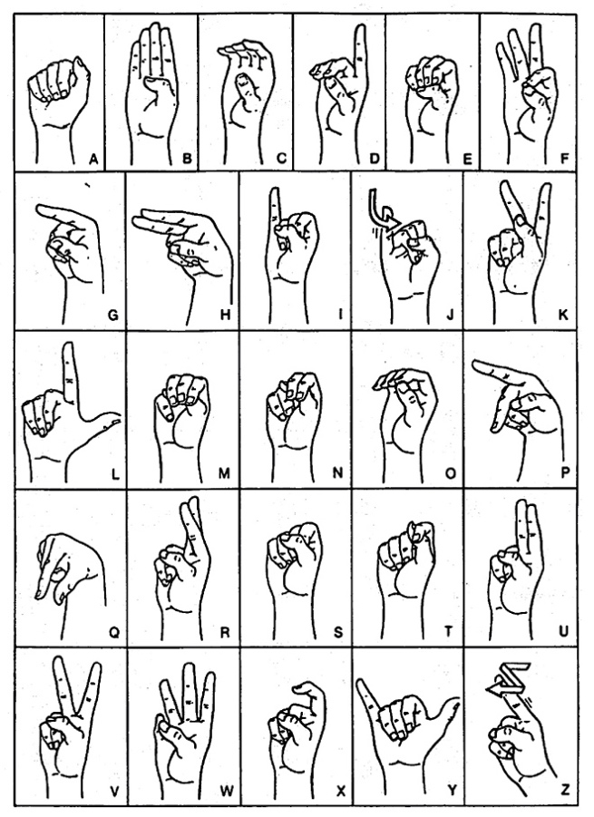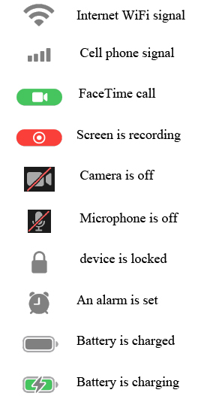
- Emojis: Are they a code? What do you use them for? Where did they come from?
“Emoji” means “picture-word” in Japanese, and they are based on Manga characters.
Individual activity: write down a few of your favorite emojis, and create a key that explains what each one means.
- Positional number systems: Hindu (only 10 symbols) vs. Roman (new symbol for each column: X, C, M) Positional requires symbol for empty column. Roman numbers are not usable for computation – used abacus instead.
Group Activity: Add 48 + 79 in decimal.
Now try adding the Roman equivalents, XLVIII + LXXIX. What goes wrong?
Individual Assignment: in your journal, discuss the advantage of using a positional numer system.
- Number bases other than 10
Individual activity:
Identify the number base or bases used in each of the following systems
- Measurement of time (How many seconds are there in a minute? Minutes in an hour? Hours in a day? Days in a week?)
- Subdivisions of a gallon (How many cups are there in a pint? Pints in a quart? Quarts in a half gallon? Half gallons in a gallon?) See chart below:

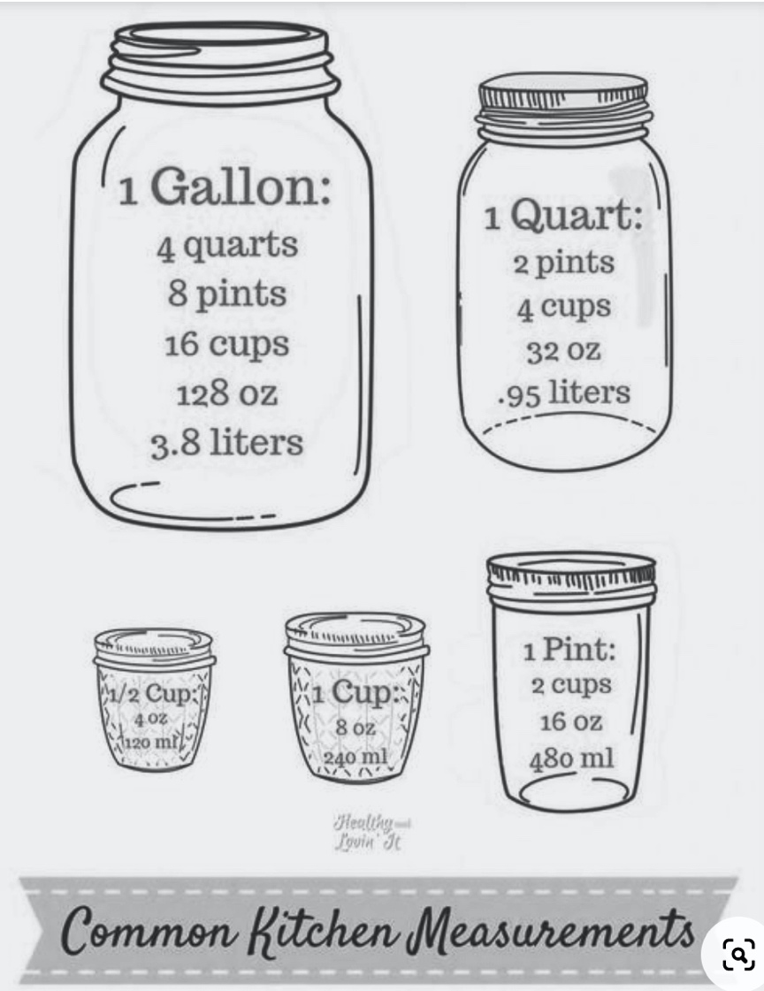
- Tally marks: (How many lines do you draw before you start over? How are the Chinese tally symbols similar and different from ours?)



- Place value: This is the meaning of each column in the decimal and other positional number systems.
Whole Class Activity
Develop a chart showing the place values of each column in the decimal number system. An example is shown below.
Decimal place value of each column |  |  |  |  |  | Decimal number
100,000 | 10,000 | 1000 | 100 | 10 | 1
0 | 0 | 0 | 0 | 0 | 1 | 1
0 | 0 | 0 | 0 | 1 | 0 | 10
0 | 0 | 0 | 1 | 0 | 0 | 100
0 | 0 | 1 | 0 | 0 | 0 | 1000
0 | 1 | 0 | 0 | 0 | 0 | 10,000
1 | 0 | 0 | 0 | 0 | 0 | 100,000
How big a group does each column represent in the decimal system? The answer is called the place value of that column. For decimal, these are shown in the highlighted row below. An easy way to see it is to put a 1 in that column, and zeros in the others. Then read across that row and it will give you the place value of the only column with a 1 in it.
Class discussion:
- To get to the next place value to the left what number do you multiply by?
- Introduction to binary: Each switch in a computer has only two possibilities: ON or OFF. These can be represented by the binary numbers 0 and 1.
Class Discussion
Now let’s look at the place values in binary. We’ve already seen that the first two columns count groups of 1 and 2, moving right to left. If we add one to two, we will get 11, which is equivalent to 3 in decimal. Now we’ve run out of symbols again, so we add another column, which represents 4. We run out again at 8 and 16. The first six columns are shown below.
Binary place value of each column |  |  |  |  |  | Decimal equivalent
32 | 16 | 8 | 4 | 2 | 1
0 | 0 | 0 | 0 | 0 | 1 | 1
0 | 0 | 0 | 0 | 1 | 0 | 2
0 | 0 | 0 | 1 | 0 | 0 | 4
0 | 0 | 1 | 0 | 0 | 0 | 8
0 | 1 | 0 | 0 | 0 | 0 | 16
1 | 0 | 0 | 0 | 0 | 0 | 32
In binary, what do you have to multiply by to get from each place value to the next one to the left?
- Binary number cards:
These use black dots to express the place values of the each of the first five binary columns:
Place values | 16 | 8 | 4 | 2 | 1
Binary cards | 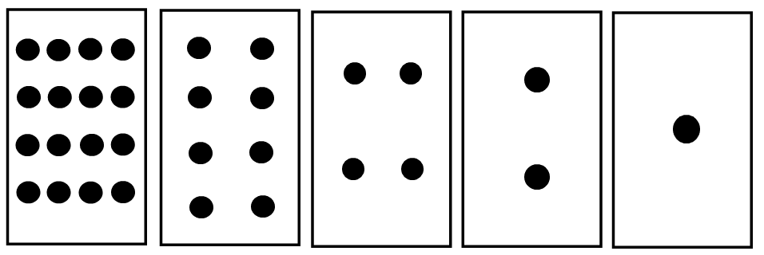
A template for making binary cards and instructions for using them appear on p. 16. You can use these cards to convert from binary to decimal, decimal to binary.
To convert from binary to decimal, write the binary number below the cards, one 0 or 1 per card, turn over the cards that show 0. Then add the place values that have 1’s, ignoring those that have 0. For example, if the binary number was 10011, the 0’s would tell you to turn over the cards with 8 dots and 4 dots. Adding up the numbers on the face-up cards, you would get 16 + 8 =2 = 26.
To go from decimal to binary, identify the cards you need to build up to the original decimal number. Leave these cards face up, and turn the others face down. Then write a 1 below the cards you need to make your decimal number, and zero for those that are turned over, and read the binary number from left to right. For example, if the decimal number was 19 = 16 + 2 + 1, you would need the 16, 2 and 1 cards only. You don’t need the 8 or 4 cares, so those would go face down. Writing 1’s for the face-up cards, and 0 for the others, reading from left to right would give you 10011, which is the binary equivalent of 19. See the table below:
Place values | 16 | 8 | 4 | 2 | 1
Binary cards | 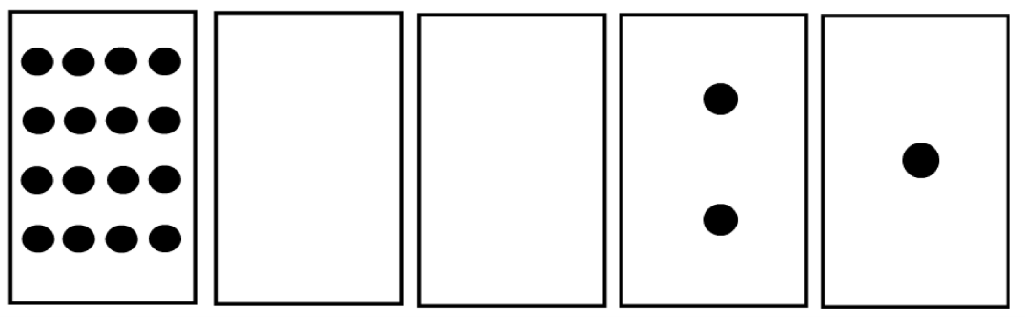
Binary number | 1 | 0 | 0 | 1 | 1
Decimal number | 16 |  |  | 2 | 1
- Binary birthdates
Individual activity: Use the binary cards to express your birthdate (day of the month only) in binary. Then let others convert from binary back to decimal to see if they can decode your birthdate.
Class discussion:
- Is there any birthdate that cannot be translated to a five-bit binary number?
- Which five-bit binary number does not translate into a possible birthdate?
- Binary birthdates lit (pre-requisite: Electric Puppets, pp.8 – 9
Individual activity:
Using the same method as for Electric Puppets, but using only one LED per coin battery, create an LED display showing your birthdate in binary. The numbers 0 and 1 could be represented by using different color LEDs, or LEDs ON and OFF. The lights should come on when the board is pressed down on a table. The photo below shows an example. sample made by a fourth grader. Her birthdate is 01111 in binary, which translates to 15 in decimal.
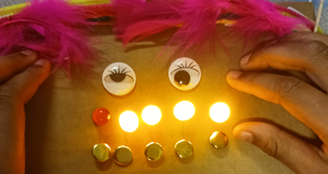
Binary birthdate in lights, made by a fourth grader.
Template and directions for making binary cards
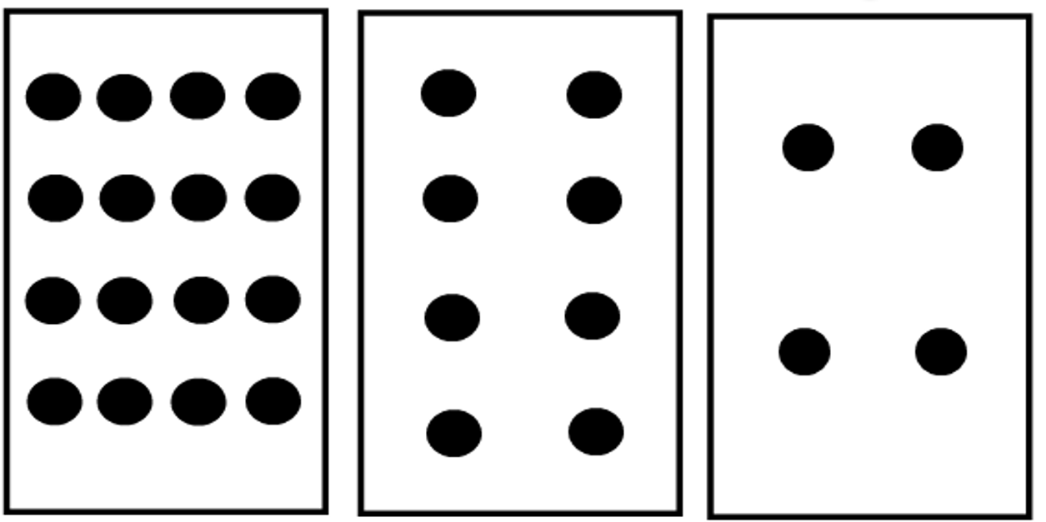
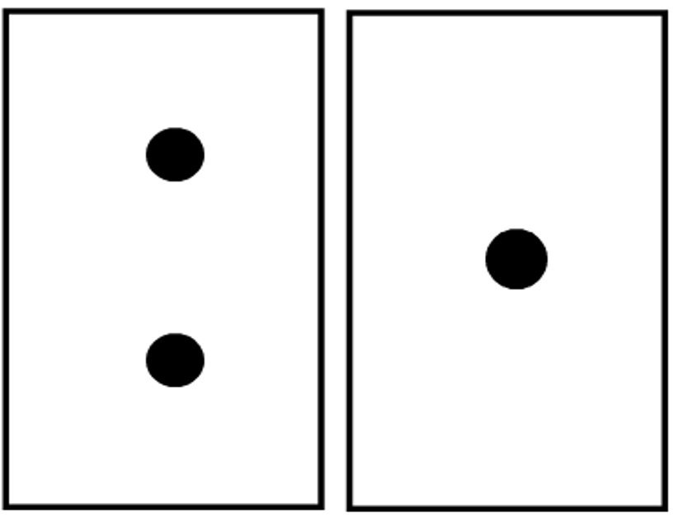
- Use a scissors to separate the five rectangles above
- Glue each rectanggle on its own index card
- Arrange the rectangles in row starting with sixteen at the left, and counting down to one on the right. These cards represent the binary place values: 16, 8, 4, 2, 1 from left to right.

Information
Materials
Set of 15 counters or pennies (one per student)
Collection of common analog or digital devices, such as switches, eye droppers, spring scales, tweezers, clothespins, hole punchers, bottle caps, tape measures (one set per group)
Worksheets: a) Seven-segment display (p. 21); b) 14-segment display (p. 22); c) 5 x 7 grid (p. 23)
d) Guess my Number (p. 25)
Template: 7 x 7 grid of 1” squares (p. 24). These may be glued to cardstock to make them last longer.
Large box of crayons, enough for at least seven crayons per student
- What is information?
Information is conveyed by any meaningful change or difference in the environment. Examples: a telephone ringer, a doorbell, an alarm clock, a basic traffic light (red or green), an alarm clock and a light switch, “ring bell for service”, bicycle or car horn, “Walk/Don’t Walk” each has two possible states, on or off, and contains the most basic unit of information: presence or absence of a signal. Each one can be represented by one binary digit, 0 or 1, or one bit of information.
Group Activities:
a) Identify other devices that contain only one bit of information.
b) Modify each one so it contains more than one bit.
Class discussion:
a) Under what circumstances could silence convey information?
b) What meaning is conveyed by common hand gestures?
- Analog vs. digital information
An analog device can change information can change continuously, such as a dimmer switch; while a digital device has only two states, ON or OFF, such as a light switch.
Class discussion:
- Look at a clock or watch. Is it analog or digital?
- How can you tell?
Group activity:
Provide each group with a similar set of analog and digital devices. Their task is to sort these items according to whether they are analog or digital. List each group’s results on a sheet of chart paper, and ask the groups to de=defend their choices, especially when there are disagreements between groups.

- Guess my Number Game (pre-requisite: Introduction to binary and Binary number cards Pp. 13-15)
Information is measured by the number of binary digits (bits) needed to include all the possible alternatives. For example, when we represented a birthdate in binary, we needed five bits, because the range of birthdates is from 1-31, and five bits can represent any number from 0 – 31. We could use the same measure for other forms of information, such as letters, number symbols, punctuation, a set of emojis, etc. The Guess my Number Game explores how many YES or NO questions, or bits, is contined in a number that can range from 1 – 100.
Group Activity: Playing the Game within each group
- Students work in groups of three. Each group member gets a different role: i) the Secret Keeper, ii) the Questioner and iii) the Recorder.
- The Secret Keeper in each group picks a number from 1 to 100, writes it down, but doesn’t tell the others what the number is.
- The Questioner asks the Secret Keeper series of YES/NO questions until he or she determines the secret number. The goal of the game is to find out the number using the least number of questions.
- The Recorder writes down each of the questions, plus the Secret Keeper’s answer.
- Once each group has played the game, the groups share the number of questions needed by each questioner. These numbers go up on chart paper.
Class Activity: The teacher plays against the class
To keep track of each step, students can use the Worksheet on p. 25. Next, the instructor plays the game against the class. While the instructor is not listening, the class selects a secret number from 1 to 100, and writes it down. The instructor returns and asks a series of questions:
- Is the number odd? If the answer is YES, her or she writes a 1 on a chart, otherwise a 0.
- The instructor tells the class to divide the number by 2 if the number was even. If it was odd, the class is told to subtract 1 and then divide by 2.
- Next the class looks at the result of doing step b). Is the result even? If so the instructor writes a 0 under the first 0 or 1; if it is odd, he or she writes a 1.
- Then the instructor asks the class repeat b) and then c) until the class reaches a result of 1, at which point the process stops.
- The instructor then informs the class of the secret number by writing the binary number from left to right, starting at the bottom, and translating it into decimal. See p. 25 fpr a Worksheet and an example.
The maximum number of questions is 7, which is the minimum needed to guess any number between 1 and 100. This number is often less than the number the students used when they played the game.
- Measuring information: Seven is the maximum number of questions needed for the teacher’s method, because each question divides the answers into nearly equal possibilities, so there is no wasted information. Because only seven binary numbers can represent a number from 1 to 100 tells us that a number from 1 to 100 contains seven bits of information.
Group Activity: Re-form the same groups as in #3, but this time use the instructor’s method.
- Information content of written English: There are 26 letters in the language. If we add SPACE, plus five punctuation marks (which ones?) you get to 32 possibilities, which can be represented by 5 binary digits or bits.
Group Activity: Create a 5-bit binary code that represents all 26 letters, plus SPACE and 5 punctuation marks of your choice. The use it this code to send a short secret message (a few words at most) within your group. Then give the same secret message to another group. Can a member of another group crack the code?
- Morse code: Morse code consists of dots (short bursts) and dashes (longer bursts). Here is a key to Morse Code:
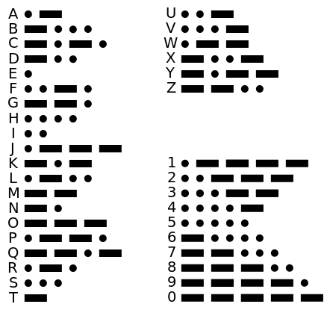
You might be wondering how letters, words and sentences are separated in Morse code. Since Morse code is sent by a telegraph key, a short pause – the length of a dash – indicates a space between letters, while a longer pauses – three dashes – indicates a space between words. The end of a sentence is indicated by the word STOP.
Group Activity: Write a short message and translate it into Morse Code. Then exchange messages among groups. Can another group decode your message?
8) Representing letter and number symbols:
  - Seven-segment displays: Where do you find them? What letters or numbers can it represent? How many bits are required to display a number on a 7-segment display?
Individual Activity: Use crayons to represent each of the ten number symbols numbers by arranging them in the shape of a seven-segment display. Record the results by darkening the appropriate rectangles a-g, on the Seven-segment Worksheet (p. 21).
- Show how each of the number symbols, 0 through 9, can be represented using seven segments.
- What upper-case letters can you also represent?
- What letters can't you represent? What goes wrong?
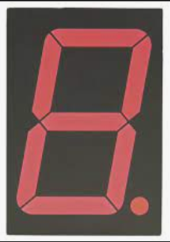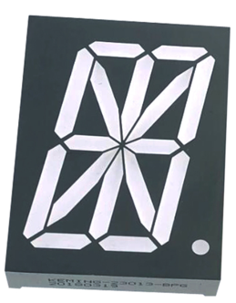
Seven-segment display (left) and 14-segment display (right)

  - The 14-segment display uses twice as many segments to display a character. They appear on microwaves, printers and other appliances. Use the 14-Segment Worksheet to explore what letters and numbers it can display.
Individual Activity: Represent as many numbers and letters as you can using the 14-Segment Display worksheet (see p. 22)

  - More possibilities are offered by the 7 x 5 matrix array. These displays are often found on food trucks, store windows, buses and trains. Use the middle 5 columns of the 7 x 7 1” grid sheets to find out what characters you can show using a 7 x 5 array. Then transfer the results to the 7 x 5 grid worksheet. An example is shown below.
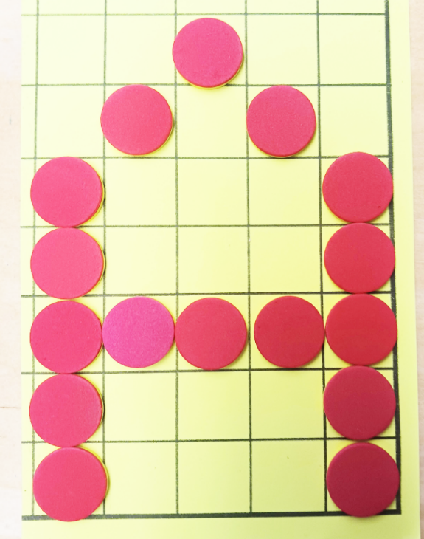
Representing “A” on a 7 x 5 grid

Seven-segment Display Worksheet

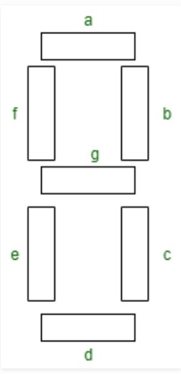

14-segment Display Worksheet
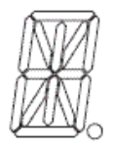

7 X 5 Grid Worksheet
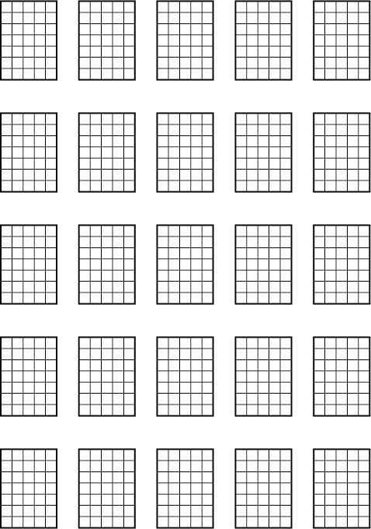

Template for making 7 x 7 grid sheet with 1” squares
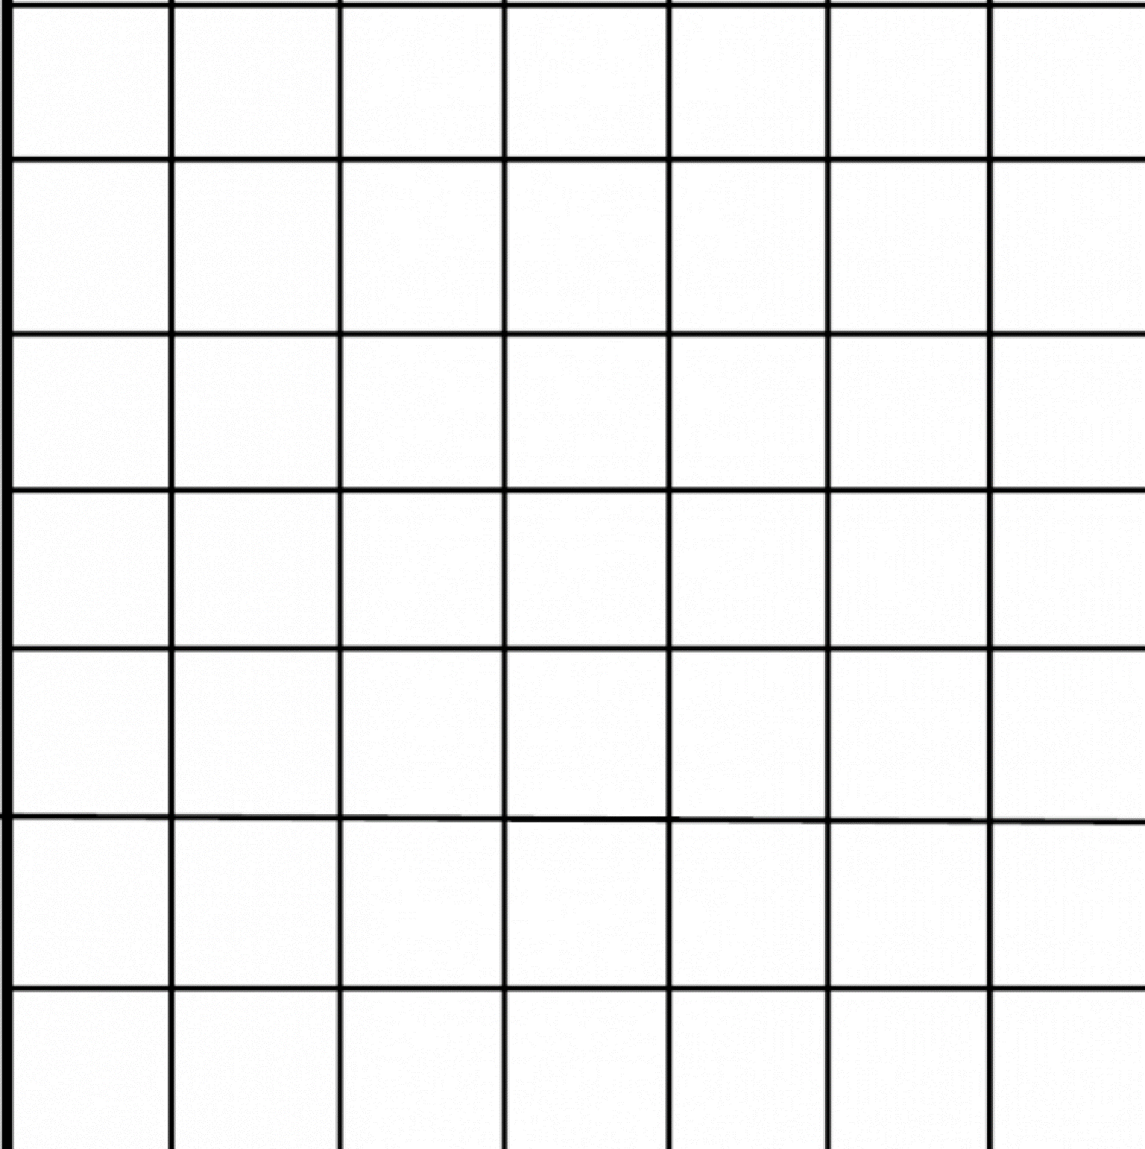

Guess My Number Worksheet and Example
Row | Is the number odd? Write YES or NO | Directions | Result | Binary  Column  (0 or 1)
1 |  | If the answer is YES, write a 1 in the Binary column, then subtract 1 from the number and divide the new number by 2. Write the answer in the Result column.  If the answer is NO, write a 0 under Binaryb, and divide by 2 Write the result in the next column to the right.
2 |  | Repeat the directions from Row 1. Stop when the result is 1. You will not need more than 7 rows.
3
4
5
6
7

Converting the Binary column to Decimal
- Write the 0’s and 1’s from the Binary column (above right) in the top row below. Use the color code to align the numbers from top to bottom above in the cells from right to left below. If the Binary column is blank, write a 0.
- Add the place values in the bottom row that have 1’s above them that have 1’saboe them. Ignore the 0’s in the Binary Row.

Binary row
Place value | 64 | 32 | 16 | 8 | 4 | 2 | 1

Example: If the number in the Binary Column is 0 1 1 0 1 0 1 from top to bottom, the table above would look like this
Binary row | 1 | 0 | 1 | 0 | 1 | 1 | 0
Place value | 64 | 32 | 16 | 8 | 4 | 2 | 1
The result in decimal would be (from left to right): 64 + 16 + 4 + 2 + 0 = 82.

Communication
Materials
Set of 35 Two-color counters (one set per group)
Template for making 7 x 7 grid sheet (see p. 24)
- What is the purpose of communication? Develop the idea that communication is the method of getting information from one place to another.
- Communication without technology:
What are the ways we can communicate among ourselves? Review the five senses.
Group activity:
Divide into pairs. One person will send some information, and the partner will receive it. Then the partners exchange roles. Each pair answers these three questions:
- What part of the body do you use to send it?
- What part or sense do you need to receive it?
- How does the information travel from one person to another?
Whole class activity
Make a chart showing the answers to these questions from representative pairs.
- Source, receiver and channel: The three questions above identify the source (body part or device that sends information), receiver (device or sense that receives information) and channel (medium that carries the information from source to receiver).
Whole Class Activity: Identify source, receiver, encoder, decoder for each channel.
- Errors in everyday communication.
Class Discussion: What are some ways communication can go wrong? Here are some sample answers:
- Speaking and listening: speaker speaks too softly, use wrong words, uses poor grammar, skips words, uses a different language, etc.; listener not paying attention, hard of hearing, too far away
- Writing and reading: Writing is not legible; words are missing, words are spelled wrong, punctuation is missing; reader needs glasses, doesn’t know how to read, or is daydreaming
- Hand signals and gestures: sender and receiver don’t agree on what they mean, receiver is not paying attention, receiver is too far away
- Touching and feeling: receiver does not want to be touched or misinterprets meaning of touching
- Signal vs noise: A useful message is called a signal, and everything else – the part we “filter out” or simply ignore – is called noise.
Class discussion
Think about some of the messages you received today. How much was signal and how much was noise? How could you tell which was which?
Group Activity:. Students work in groups of three. Identify one member of the group as the sender (source), the second as the channel, and the third as the receiver.
  - On a piece of paper, the sender writes a short message to the receiver..
  - The channel erases one or more words from the message, or rewrites the message without those words.
  - The receiver tries to interpret the message with the words missing, and checks with the sender to see if he or she got it right.
- Redundancy. Repeating a message more than once is a strategy for avoiding errors in communication is to or add extra information. This strategy is called redundancy.
Class discussion: Ask for examples of redundancy in everyday communication, for example:
- As a teacher, do I ever repeat my instructions to the class, or add extra information to make them clearer? Provide examples.
- Do you add extra information when to talk to your friends, either on the phone or in person? When do you do this, and what is the redundant information?
- Introduction to Parity (pre-requisites: Introduction to binary, Binary Cards and Binary Birthdates, Pp. 13-14)
Parity is the simplest form of error detection used by computers. Suppose you want to send someone your birthdate in five-bit binary, using a combination of 0’s and 1’s. These five numbers, which could each be 0 or 1, are called bits. To guard against errors, you add a redundant sixth bit at the end, called a parity bit. To create the parity bit, count the number of 1’s within the five-bit message. If the count is odd, make the parity bit a 1. If the count is even, make the parity bit a 0. For example, if your message was 01010, your parity bit at the end, would be 0, giving 010100, because the number of 1’s was 2, and even number. If you wanted to send 11100, the total number of 1’s is 3, an odd number, so the parity bit is 1, giving 111001.
Individual Activity: Add a parity bit to your birthdate in binary, and share the new message with the class. Is the total number of 1’s now even or odd? Ask another student to change one of the bits from 1 to 0 or 0 to 1, and give the new code back to you. How can you tell that there was an error?
- Parity Magic Trick.
Class activity:
The instructor plays a game with a student volunteer. On the blackboard or whiteboard, draw a 5 x 5 array of cells. Ask a student to place an X or an O in each cell. The instructor creates a 6th row and a 6th column, which together contain 10 parity bits, one for each of the five original columns and 5 original rows. The parity bits force the number of X’s in each of the 5 rows and each of the 5 columns to have even parity. The instructor then looks the other way while the student changes one of the X’s to an 0, or vice versa. The instructor then uses parity to identify the cell that was reversed.
Group Activity:
Students work in groups of 4, in the roles that we’ll call Sender, Channel, Receiver and Recorder. Each group receives 35 one-inch two-color counters and a sheet of 7 x 7 grid paper. This trick can work with any two colors, but let’s suppose the two colors are red and yellow. The Sender lays out 25 counters in a 5 x 5 array, with some counters yellow-side-up, and others red-side-up. The Receiver adds 10 more counters, including five at the ends of the rows, and five above the columns. While the Receiver isn’t looking, The Channel turns one of the counters upside down, changing its color. The recorder keeps a record of each game, including the original placement of the counters, the additional row and column, the counter that was changed, and the success of the detective in identifying the flipped counter. On subsequent rounds, the four students can change roles.
The photos below show a typical sequence.
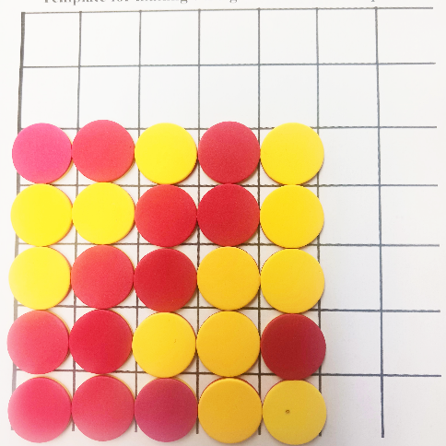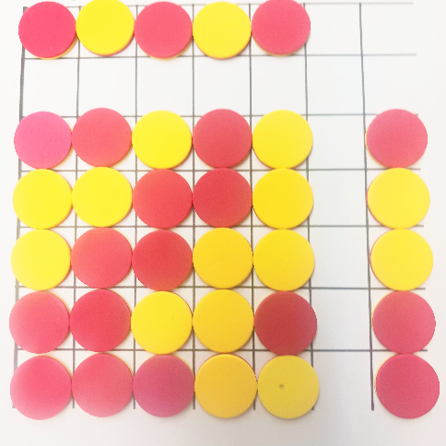
1. Original pattern 2. Parity bits added
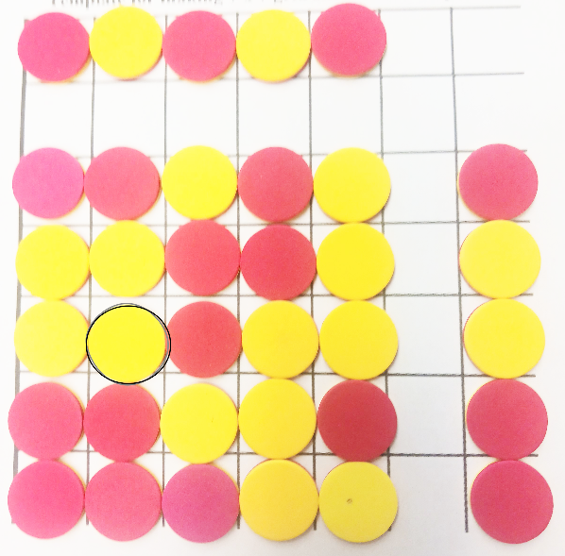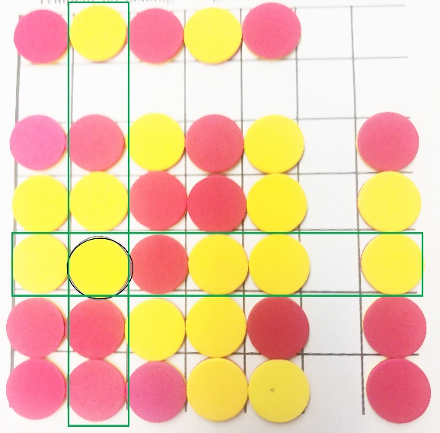
3. Error introduced (circled) 4. Error identified (row and column intersect)
In the example above, the Receiver could identify the location of the error, by noticing that the middle row and second column to the left no longer show parity, because both 1 and 3 are odd. The error must therefore be where the row and ciolumn intersect.
8. How the trick works: If the students haven’t figured it out, reveal the secret to the trick.
- Exploring further: How well would the parity method would work if there were multiple errors?
Group activity:
- Add a second error. Do an experiment to find out if the method can correct it.
- Arrange the two errors differently. Find out if the method can correct both errors if they are in different rows and columns vs. the same row or column. What goes wrong?

